TO SUPPLY LEFTOVER FOOD TO POOR

College Name : UNITED COLLEGE OF ARTS AND SCIENCE

College Code : asbrublSS

TEAM ID : NM2025TMID27771

TEAM MEMBERS :

**Team Leader Name:**

Email: darzxanaa@gmail.com

**Team Member1**:

Email : praneshkeerthana21@gmail.com

**Team Member2:**

Email : sivithak972@gmail.com

**Team Member3:**

Email : ragavan5537@gmail.com

**Team Member4**:

Email : aswithapradeeksha06@gmail.com

**1.INTRODUCTION :**

1.1 PROJECT OVERVIEW:

Every day, countless meals are thrown away—perfectly edible, untouched food that could have filled an empty stomach. At the same time, millions of people go to bed hungry, not knowing where their next meal will come from.

**To Supply Leftover Food to Poor - mission is to connect individuals, restaurants, events, and food providers with local communities in need**.

1.2 PURPOSE:

This isn't just an app. A platform built with compassion, powered by community, and driven by the belief that no food should go to waste while people are still hungry.

"Together, we can turn leftovers into lifelines."

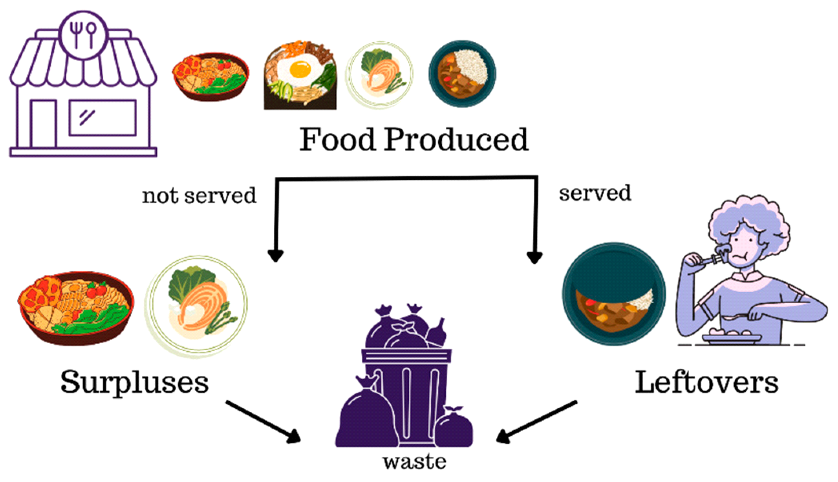

**1.3 DEVELOPMENT PHASE**

Creating Developer Account :

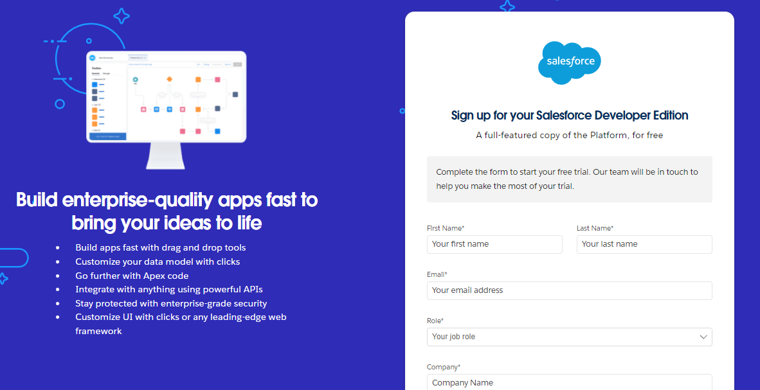sg

* 1.4 OBJECTS :
* To create an object: Venue
* To create an object: Drop off Point
* To create an object: Task
* To create an object: Execution Details
* To create an object: Volunteer

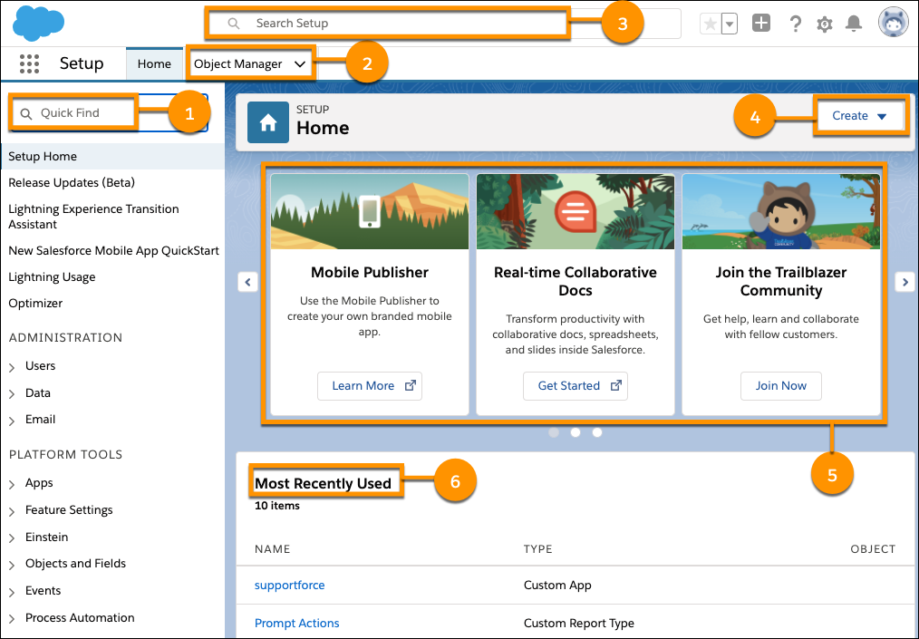

* From Setup >> Object Manager >> Click on Create>> Click Custom Object

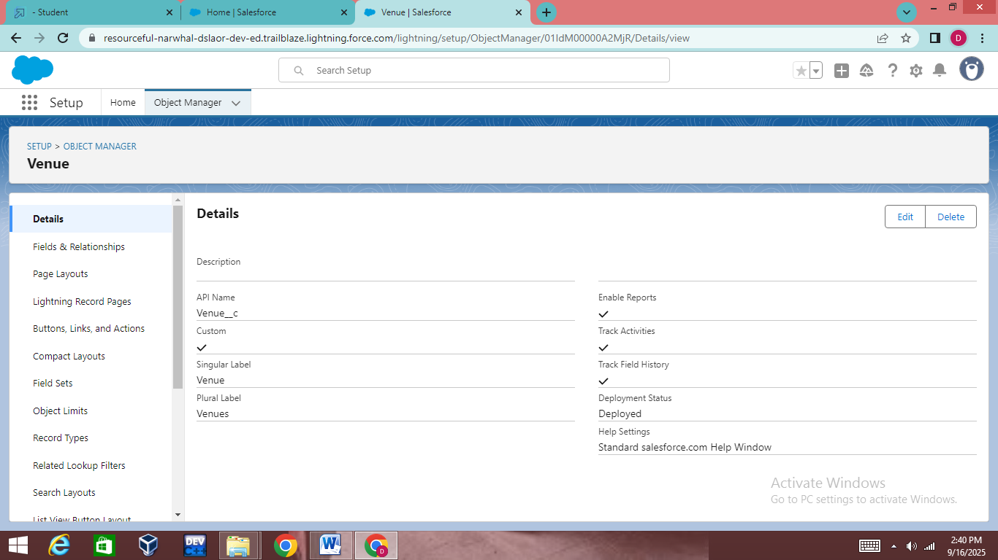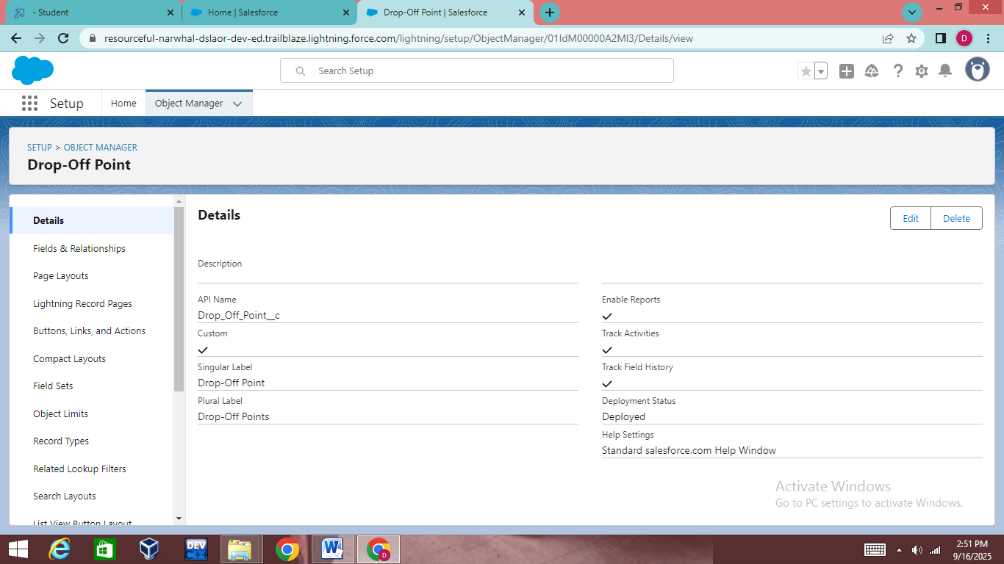

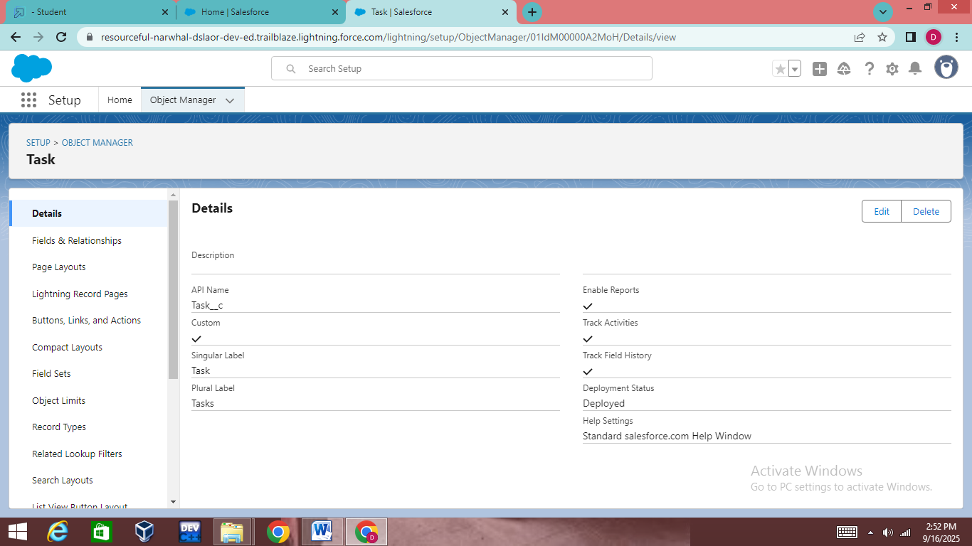

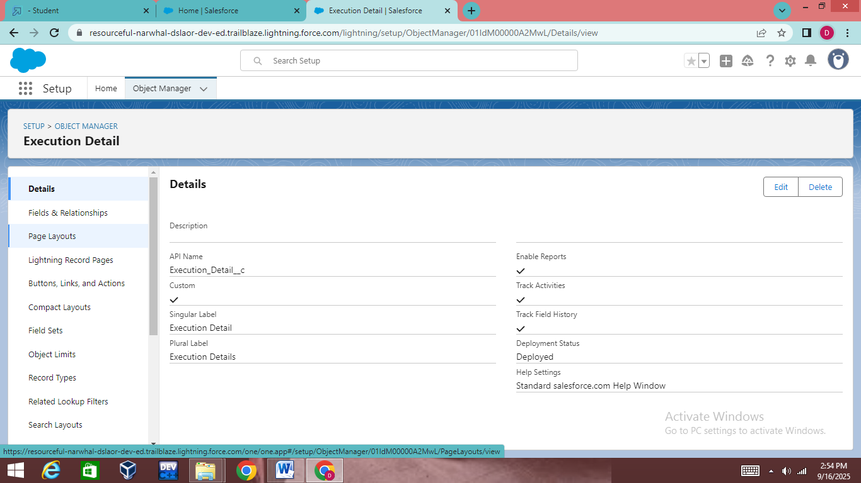

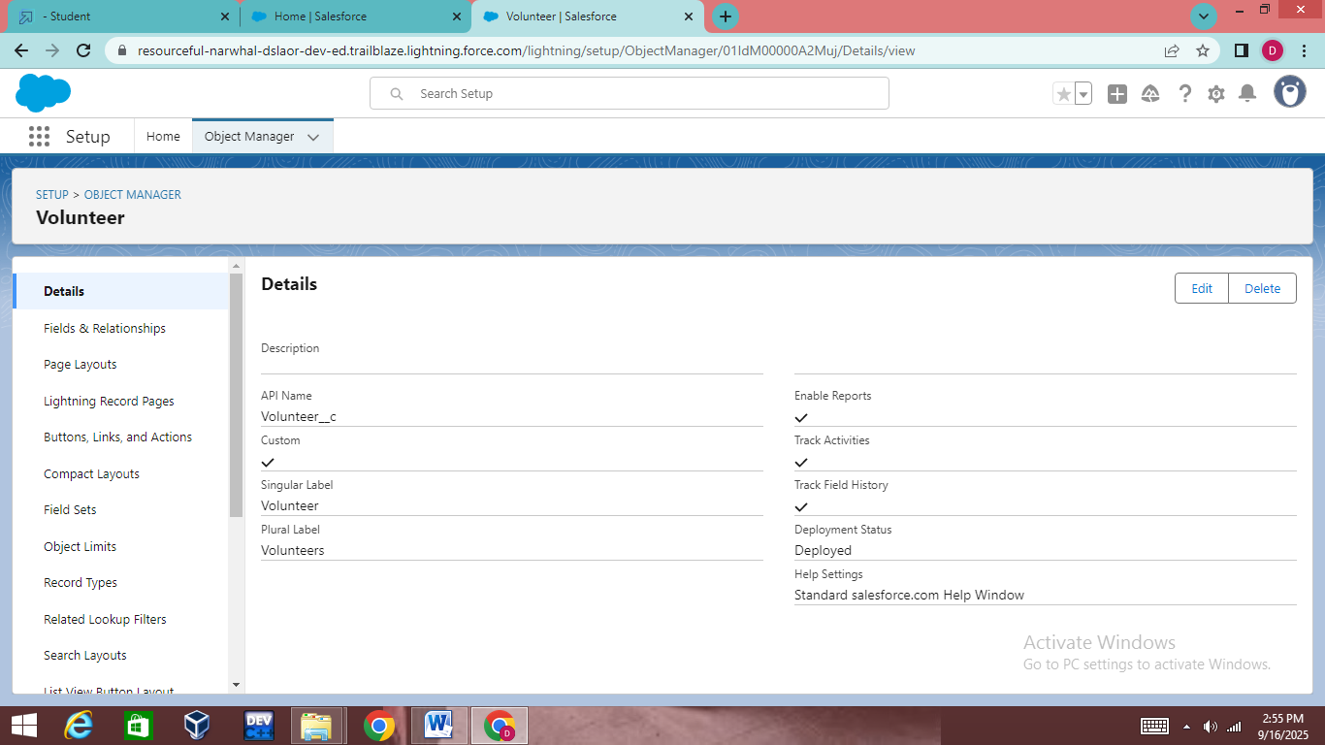

* The Objects Venue, Drop Off point, Task , Execution Details, Volunteer are Created.

**1.5 TABS**

To create a Tab:(object name )

* Go to setup page >> type Tabs in Quick Find bar >> click on tabs >> New (under custom object tab)

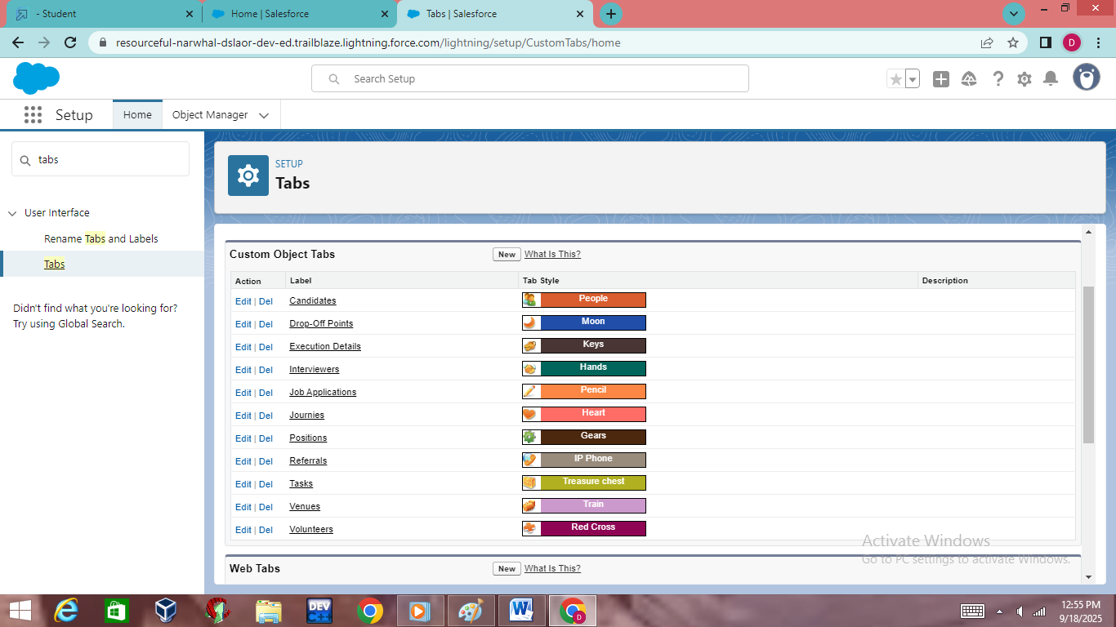

1. Select Object(object name ) >> Select the tab style >> Next (Add to profiles page) keep it as default >> Next (Add to Custom App)  uncheck the include tab .
2. Make sure that the Append tab to users' existing personal customizations is checked.
3. Click save
4. Do the same procedure for selecting the tab for all the object that has been created .

### 1.6 CREATE A LIGHTNING APP

### 

1. Go to setup page >> search “app manager” in quick find >> select “app manager” >> click on New lightning App.
2. Fill the app name in app details and branding as follow  
   App Name : FoodConnect  
   Developer Name : This will auto populated  
   Image : optional (if you want to give any image you can otherwise not mandatory) Primary color hex value : keep this default.
3. (Utility Items) keep it as default >> Next.
4. To Add Navigation Items:
5. To Add User Profiles:

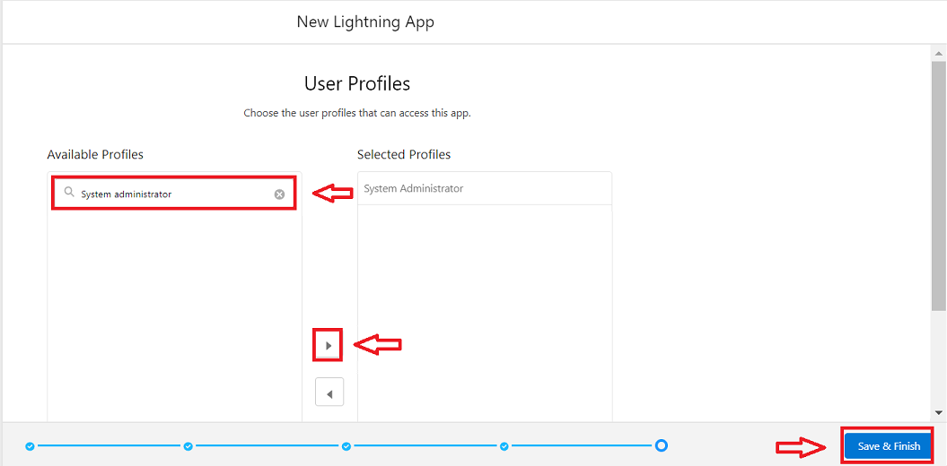

Search profiles (System administrator) in the search bar >> click on the arrow button >> save & finish.

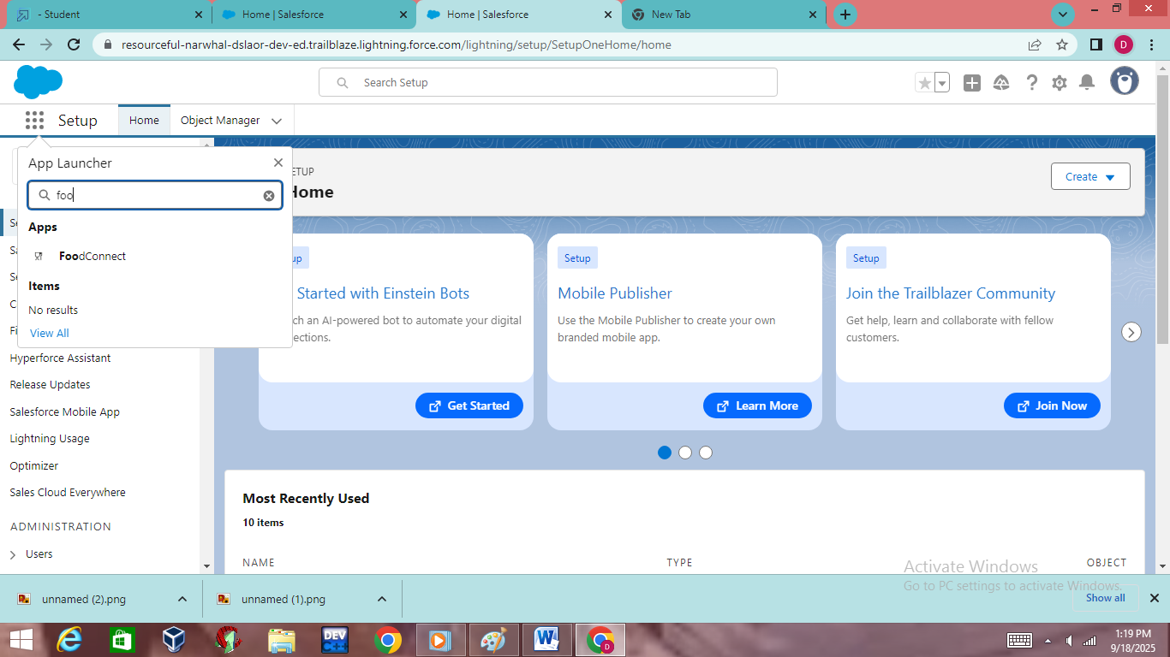

The app named FOODCONNECT has been created.

### 1.7 Creation Of Relationship Fields In Objects

### 

### Create Flow To Create A Record In Venue Object

1. Go to setup >> type Flow in quick find box >> Click on the Flow and Select the New Flow.
2. Select the Screen flow. Click on create.

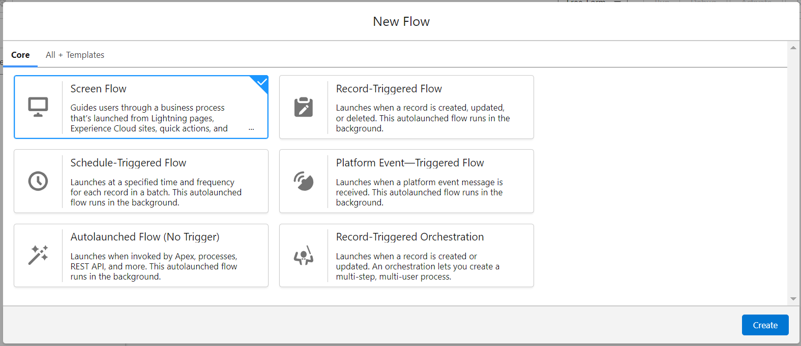

1. Click on the ‘+’ icon in between start and end, and click on screen element.
2. Under the Screen Properties:

Label : Venue Details

API Name : Venue_Details

1. Now lets add components in this flow. Click on Text Component and name it as:

Label : Venue Name

API Name : Venue_Name

1. Click on Email Component and name it as:

Label : Email

API Name : Contact_Email

1. Click on Phone Component and name it as:

Label : Phone

API Name : Contact_Phone

1. Click on Text Component and name it as:

Label : Venue Location

API Name : Venue_Location

1. Click on Number Component and name it as:

Label : Latitude

API Name : Latitude

1. Click on Number Component and name it as:

Label : longitude

API Name : longitude

1. Next click on Done. This would like below

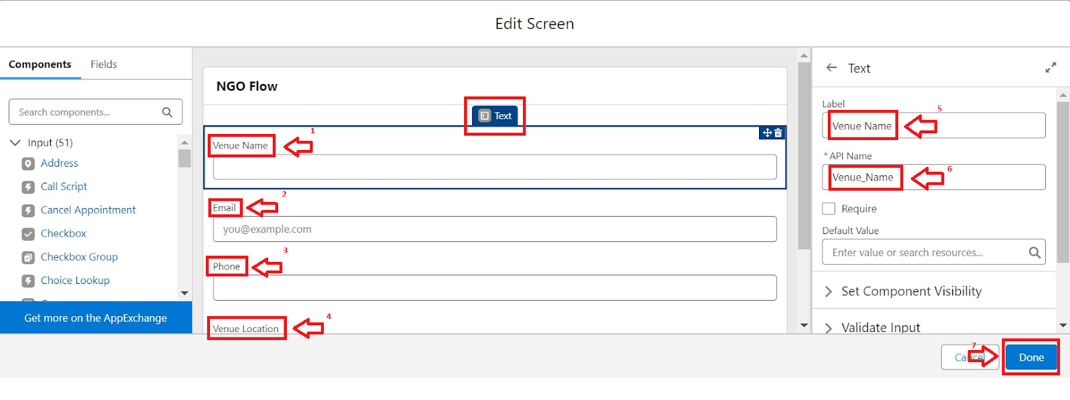

1. Click on the ‘+’ icon in between Venue details and end, and click on create record element.
2. Now label it as

Label : Create Venue Record

API Name : Create_Venue_Record

How Many Records to Create : One

How to Set the Record Fields : Use separate resources, and literal values

Object : Venue

Set Field Values for the Venue : Click on ‘Add Field’ 5 times

Field : Value = Contact_Email__c : {!Contact_Email.value}

Field : Value = Contact_Phone__c : {!Contact_Phone.value}

Field : Value = Name : {!Venue_Name}

Field : Value = Venue_Location__c : {!location}

Field : Value = Location__Latitude__s : {!latitude}

Field : Value = Location__Longitude__s : {!longitude}

1. This would look like:

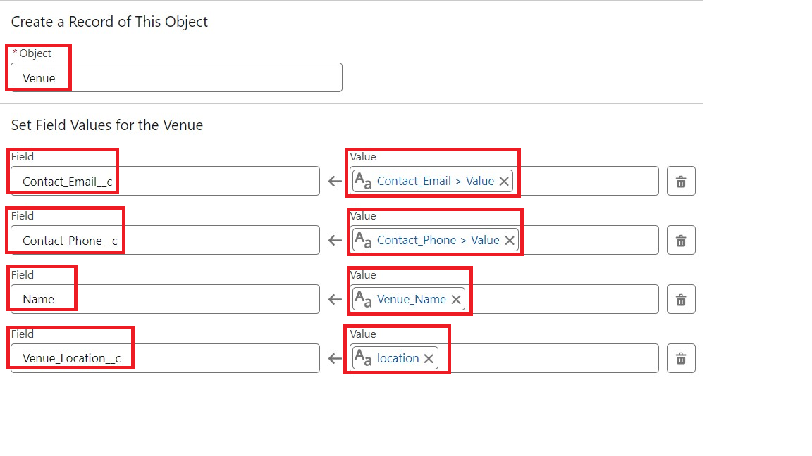

1. Click on Save as:

Flow Label : Venue Form

Flow API Name : Venue_Form

### Create A Trigger

1. Log into the trailhead account, navigate to the gear icon in the top right corner.
2. Click on developer console and you will be navigated to a new console window.
3. Click on the File menu in the toolbar, and click on new >> Trigger.
4. Enter the trigger name and the object to be triggered.

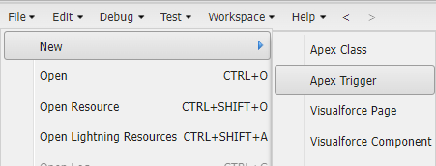

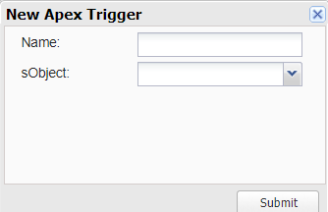

1. Enter Name : DropOffTrigger

sObject: Drop-Off Point

1. Click on Submit.

### Trigger Code

(This Trigger is to assign Distance field to the Distance Calculation field. So that we can assign the distance in the sharing rules.)

**Code:**

trigger DropOffTrigger on Drop_Off_point__c (before insert) {

    for(Drop_Off_point__c Drop : Trigger.new){

        Drop.Distance__c = Drop.distance_calculation__c;

    }

}

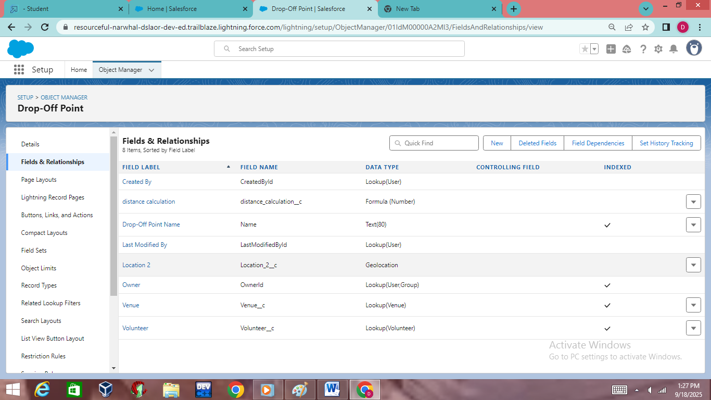

### Trigger Code

(This Trigger is to assign Distance field to the Distance Calculation field. So that we can assign the distance in the sharing rules.)

**Code:**

trigger DropOffTrigger on Drop_Off_point__c (before insert) {

    for(Drop_Off_point__c Drop : Trigger.new){

        Drop.Distance__c = Drop.distance_calculation__c;

    }

}

### Trigger Code

(This Trigger is to assign Distance field to the Distance Calculation field. So that we can assign the distance in the sharing rules.)

**Code:**

trigger DropOffTrigger on Drop_Off_point__c (before insert) {

    for(Drop_Off_point__c Drop : Trigger.new){

        Drop.Distance__c = Drop.distance_calculation__c;

    }

}

### Profiles

1. Go to setup page >> type Profiles in Quick Find bar >> click on Profiles >> click on ‘S’
2. Click on Clone beside Standard Platform User.
3. Under Clone Profile:

Profile Name : NGOs Profile

1. Then click on Save

### Creation Of User1

1. Go to setup page >> type users in Quick Find bar >> click on users>> New user.
2. In General Information give details as: (Note : create users as per your wish NGO’s)

First Name : Iksha Foundation

Last Name : Iksha_Foundation

Alias : iiksh

Email : Give Your Email

Username : [ikshafoundation@sb.com](mailto:ikshafoundation@sb.com) (give the username different)

Nickname : Auto Populated

User License : Salesforce Platform

Profile : NGOs Profile

Active : Check

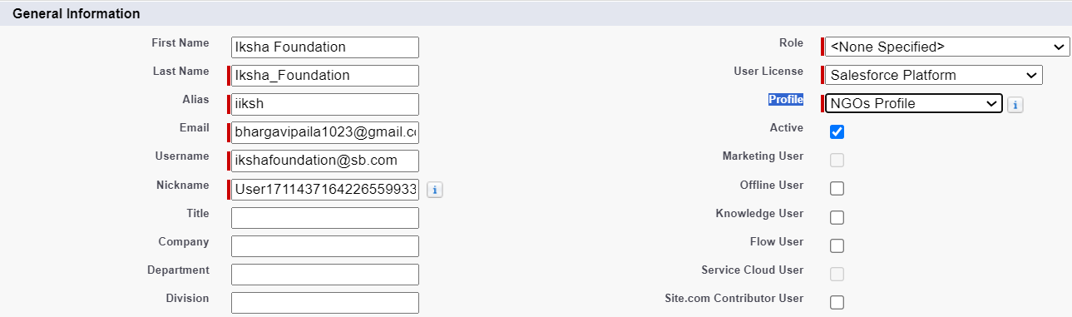

1. Click on Save

### Creation Of User2, User3

1. Create another Two Users by following steps in Activity - 1 with similar User License and Profile.
2. Give Different First Name, Last Name based on Different NGO’s.



### Creation Of Public Group 1

1. Go to setup page  >>  type Public Groups in Quick Find bar  >>  click on Public Groups >>  click on New.
2. Under Group Information:

Label : Iksha

Group Name : Iksha

Grant Access Using Hierarchies : Check

1. In Search, Select Users.
2. In Selected Members Add Iksha Foundation and System Administrator

### Creation Of Public Group 1

1. Go to setup page  >>  type Public Groups in Quick Find bar  >>  click on Public Groups >>  click on New.
2. Under Group Information:

Label : Iksha

Group Name : Iksha

Grant Access Using Hierarchies : Check

1. In Search, Select Users.
2. In Selected Members Add Iksha Foundation and System Administrator

### Creation Of Report Types

1. Go to setup page  >>  type Report Types in Quick Find bar  >> click on Report Types  >>  click on Continue   >>  Click on New Custom Report Type.
2. In Define the Custom Report Type:

Primary Object : Select Venues

Report Type Label : Venue with DropOff with Volunteer

Report Type Name : Venue_with_DropOff_with_Volunteer

Description : Venue with DropOff with Volunteer

Store in Category : Select Other Reports

Deployment Status : Deployed

1. Click on Next
2. Near Click to relate another Object Select Drop-Off Points.
3. And also select "A" records may or may not have related "B" records.
4. Now again Near Click to relate another Object Select Volunteers.
5. Now click on Save.

### Creation Of Report On Venue With DropOff With Volunteer

1. Go to the app(FoodConnect)  >>  click on the reports tab
2. Click on New Folder.

Folder Label : Custom Reports

Folder Unique Name : CustomReports

1. Open Custom Reports and click on New Report
2. Select Report Type : Venue with DropOff with Volunteer
3. Then click on Start Report.
4. In GROUP ROWS : Add Volunteer Name
5. In Columns : Add Venue Name, Drop-Off point Name, Distance.

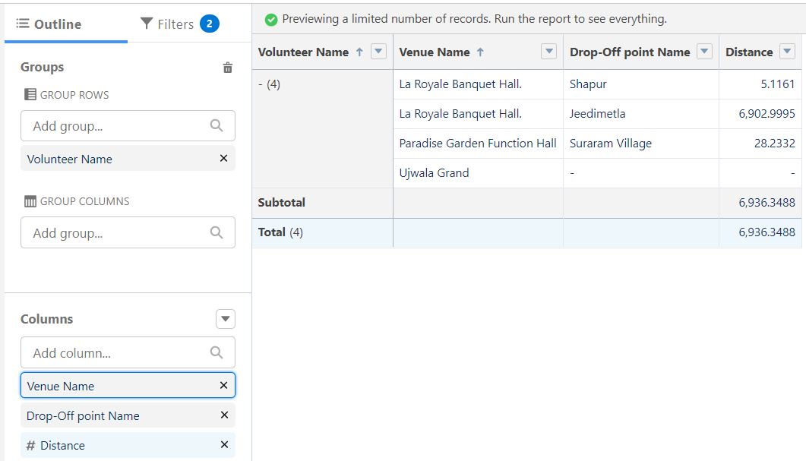

1. Now click on Save & Run.
2. Give Label as :
3. Report Name : venue and Drop Off point
4. Report Unique Name : Auto Populated
5. Click on Select Folder and select Custom Report, then click on Save.

### Creation Of Report On Volunteers With Execution Details And Tasks

1. Go to the app(FoodConnect)  >>  click on the reports tab
2. Click on Custom Reports Folder and click on New Report
3. Select Report Type : Volunteers with Execution Details and Tasks.
4. Then click on Start Report.
5. In GROUP ROWS : Volunteer ID
6. In Columns : Add Volunteer : Volunteer Name, Task : Task Name, Execution Detail : Execution Detail Name, Volunteer: Owner Name, Task: Date, Task : Rating.

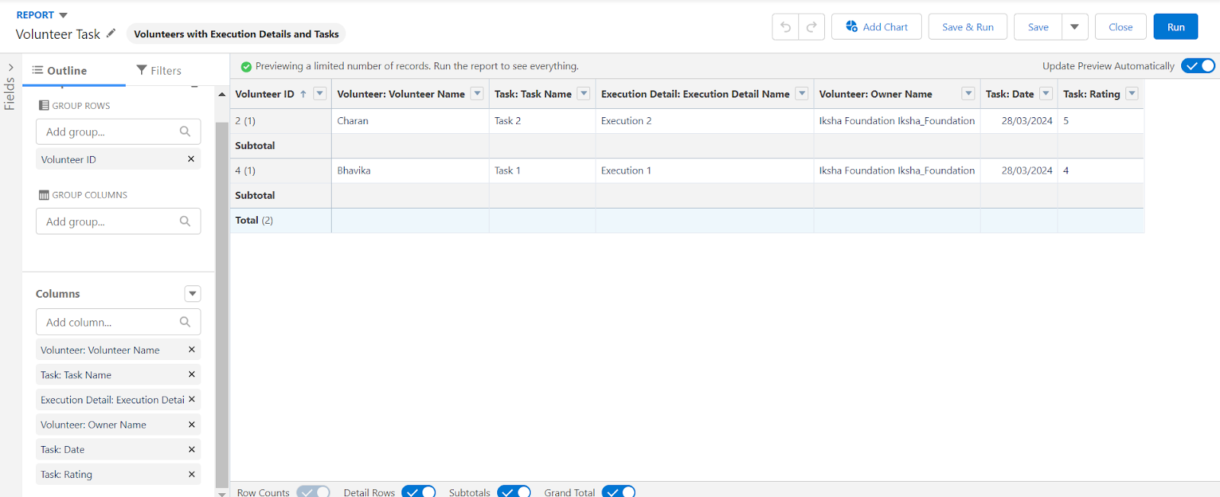

1. Now click on Save & Run.
2. Give Label as :

Report Name : Volunteer Task

Report Unique Name : Auto Populated

1. Click on Select Folder and select Custom Report, then click on Save.

### Creation Of Report On Volunteers With Execution Details And Tasks

### Adding Venue And Drop Off Point Report To The Dashboard

1. Go to the app(FoodConnect)  >>  click on the Dashboards tab.
2. Click on New Folder.

Folder Label : Custom Dashboards

Folder Unique Name : Auto Populated

1. Open Custom Dashboards and click on New Dashboards
2. Name : Organization Details
3. Click on Widget and select Chart or Table
4. In Select Report : Select venue and Drop Off point Report.
5. Then click on select
6. In Add Component:

Display As : Select Lightning Table

Component Theme : Select Dark (Optional)

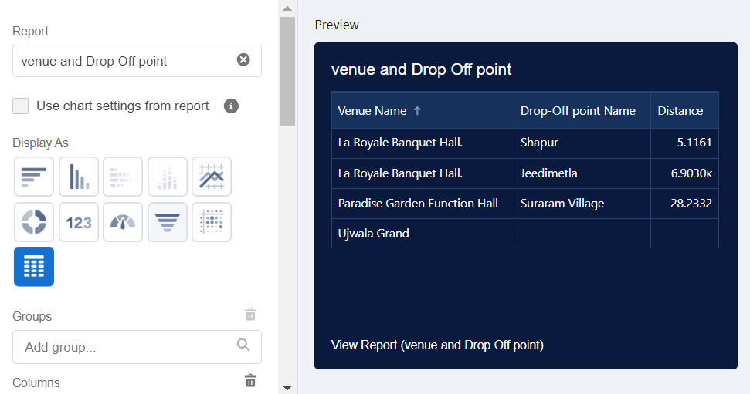

1. Now click on save.
2. Go to the app(FoodConnect)  >>  click on the reports tab
3. Click on Custom Reports Folder and click on New Report
4. Select Report Type : Volunteers with Execution Details and Tasks.
5. Then click on Start Report.
6. In GROUP ROWS : Volunteer ID
7. In Columns : Add Volunteer : Volunteer Name, Task : Task Name, Execution Detail : Execution Detail Name, Volunteer: Owner Name, Task: Date, Task : Rating.



1. Now click on Save & Run.
2. Give Label as :

Report Name : Volunteer Task

Report Unique Name : Auto Populated

1. Click on Select Folder and select Custom Report, then click on Save.

### Dashboard

1. Click on Widget and select Chart or Table
2. In Select Report : Select Volunteer Task Report.
3. Then click on select
4. In Add Component:

Display As : Select Line Chart

Component Theme : Select Dark (Optional)

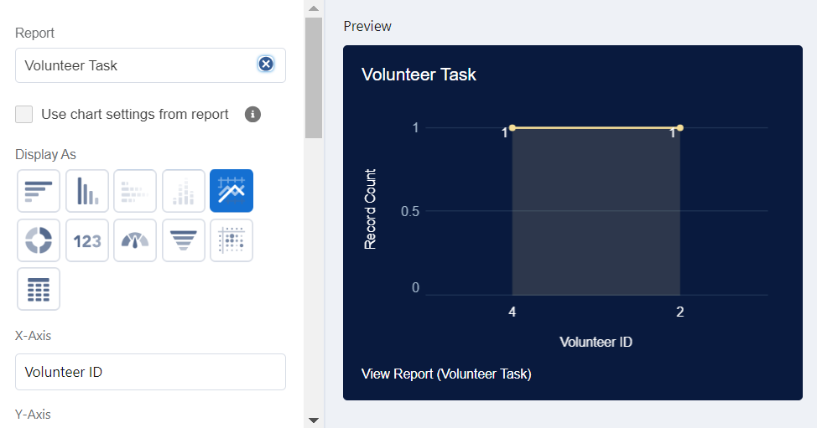

1. Now click on save.

### Creation Of Sharing Rules

1. Go to setup  >>  type Sharing Settings in quick find box  >>  Click on the Sharing Settings.
2. Scroll down and find Drop-Off point Sharing Rules.
3. Click on new near Drop-Off point Sharing Rules and Name it as:

Label : Rule 1

Rule Name : Rule_1

1. Select your rule type : Select Based on criteria.
2. Select which records to be shared:

Field : Operator : Value = Distance : less than : 15

1. Select the users to share with : Near Share With

Public Groups : Iksha

1. Click on Save.
2. Click on new near Drop-Off point Sharing Rules and Name it as:

Label : Rule 2

Rule Name : Rule_2

1. Select your rule type : Select Based on criteria.
2. Select which records to be shared:

Field : Operator : Value = Distance : greater than : 15

Field : Operator : Value = Distance : less or equal : 30

1. Select the users to share with : Near Share With

Public Groups : NSS

1. Click on Save.
2. Click on new near Drop-Off point Sharing Rules and Name it as:

Label : Rule 3

Rule Name : Rule_3

1. Select your rule type : Select Based on criteria.
2. Select which records to be shared:

Field : Operator : Value = Distance : greater than : 30

Field : Operator : Value = Distance : less or equal : 50

1. Select the users to share with : Near Share With

Public Groups : Street Cause

1. Click on Save.

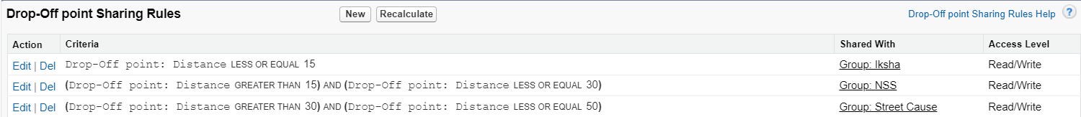

### Creation Of Home Page

1. Go to setup >> type Lightning App Builder in quick find box  >>  Click on the Lightning App Builder and Select the New.
2. Select Home Page and give Label as HOME Page.
3. Select Standard Home Page.
4. Near Components search for Flow and Drag and Drop in Right Side Section..
5. On the right hand side:

Flow : Venue Flow

1. Near Components search for Dashboard, then Drag and Drop it in first Section.

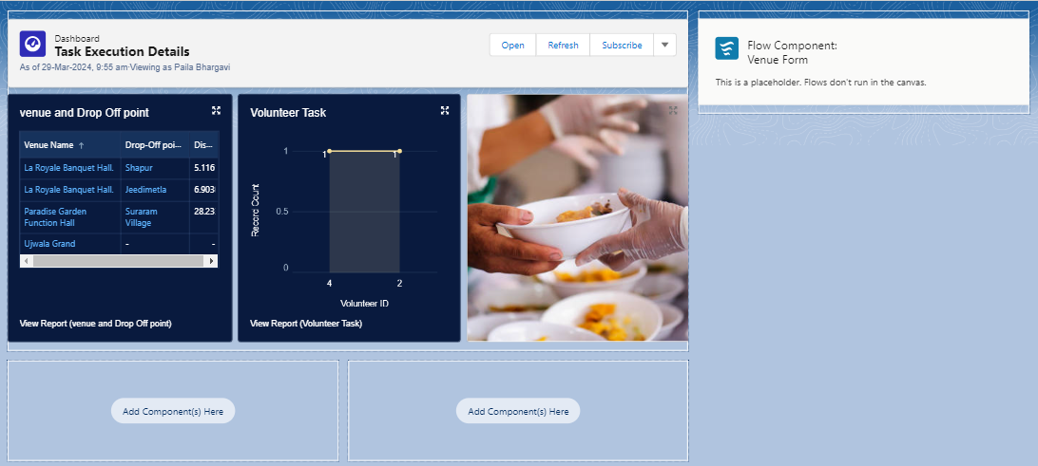

1. Click on Save and Activation, then click on App Default, then Add Assignments.
2. Add FoodConnect App and then Save.
3. FoodConnect Home Page would Look Like this.

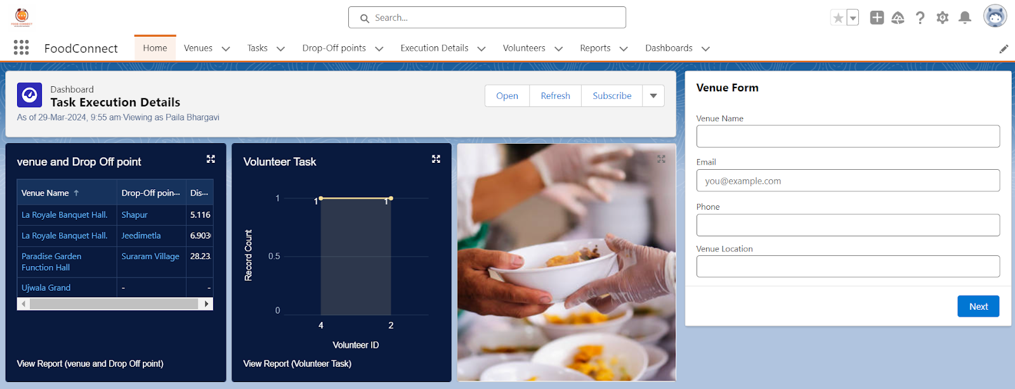

### Conclusion

By leveraging the Salesforce platform, the project successfully established a streamlined and transparent system for managing surplus food donations. Through efficient coordination with volunteers and timely delivery to beneficiaries, the project effectively addressed food insecurity while maximizing the utilization of available resources.